Digital Forensics  Diploma in CSF/IT  Year 2/3 (2025/26) Semester 4/6 | Week 3
 | Tutorial 3
Case Study: Investigating Lateral Movement

OBJECTIVES

After completing this topic, you should be able to
- Explain how the logon events are created
- Identify the location where these events can be found

Background:
In a compromised Windows environment, attackers typically leverage stolen, valid credentials (either local or domain) to move from system to system – a process known as “lateral movement”.

Many environments use common local administrator passwords for all systems, or subsets of their environment. If an attacker compromise a single system and obtain such a credential, they can move freely from host to host. Worst yet, if the attacker gains access to a domain administrator account, they may be able to access any system within the domain at will.

Case Description:

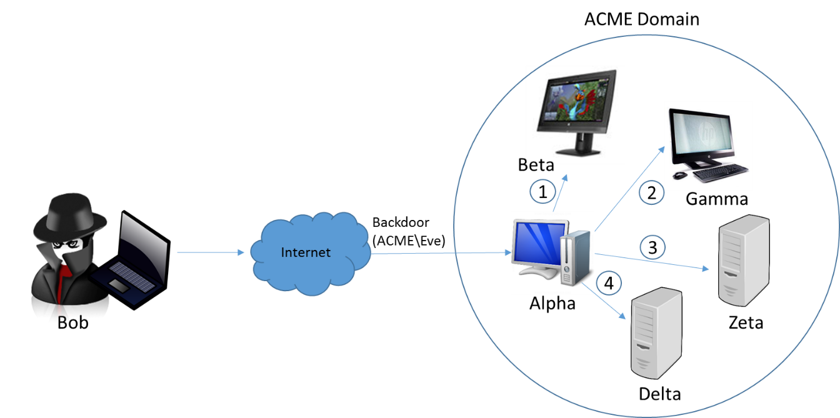

- The attacker, Bob, has interactive access to a Windows 7 workstation, Alpha, through persistent backdoor.
- Alpha is joined to a corporate domain, ACME.
- The backdoor runs under the context of the domain user who owns Alpha, ACME\Eve.
- Through password dumping and other intrusion activities, the attacker has obtained credentials for two accounts:
  - A local administrator, localAdmin, that is configured with an identical password on each workstation in the ACME domain
  - A domain administrator, ACME\domainAdmin, who has full access to all workstations and servers in the environment

Bob uses the backdoor to invoke a command shell under the context of ACME\Eve. He uses various commands, in combination with the credentials for accounts localAdmin and ACME\domainAdmin, to access four systems, each in a different manner:

- He mounts the C$ share for workstation Beta, from source system Alpha, to transfer malware and tools, using the following command:

net use \\beta\c$ /u:localAdmin “badPassword”

- He uses the SysInternals PSExec utility to remotely execute a command on workstation Gamma, once again from source system Alpha, using the following command:

psexec.exe \\gamma –u ACME\domainAdmin –p worsePassword “C:\path\to\malware.exe”

- He establishes a remote desktop connection to server Zeta, once again from source system Alpha, using the Windows built-in RDP client (username ACME\domainAdmin, password worsePassword).

- He browses to an IIS intranet web server, Delta that requires NTLM authentication. Bob uses ACME\domainAdmin credentials.

Activities:

Q1: Research online to find out the purpose and syntax of the following commands:

No. | Commands | Purpose | Syntax
1 | net use | Used to connect, disconnect and manage network resources like shared drives and printers
  net use [<DeviceName>] [\<ComputerName><ShareName> [<Password>]] [/user:[<DomainName>]<UserName>] [/persistent:{yes | no}]`
2 | psexec | to execute processes on remote Windows systems, acting as a lightweight replacement for telnet and a tool for remote administration | psexec \\<ComputerName> [-u <UserName>] [-p <Password>] <Command>

Q2: Each of the four actions carried out by attacker Bob above will result in a logon event. Complete the following table to show the Logon Type (refer to Lecture 3, slide 47) and the location where the events are logged.

Action | Logon Type | Location | Remarks
1 | 3 | Source (Alpha): Security Log  Target (Beta): Security Log | A Type 3 logon is a network logon. Accessing a network share (like C$) always generates this type. The event is recorded on both the computer initiating the connection (source) and the one providing the resource (target).  Local admin will only show on beta
2 | 3 | Source (Alpha): Security Log  Target (Gamma): Security Log | PsExec typically creates a remote service, which often results in a Type 3 (Network) logon.
3 | 10 | source (Zeta): Security Log  target (domain controller): security log | A Type 10 logon is for RemoteInteractive logons, which is used specifically for Remote Desktop Services (RDP).
4 | 3 | Target (Delta): Security Log | Accessing a web server that uses NTLM authentication is treated as a network resource access, resulting in a Type 3 (Network) logon.

- End -

